Notes & Comments for CMMS System ( name of software will be SyncShield )

- Logo , name Alignment for the Sign in Page

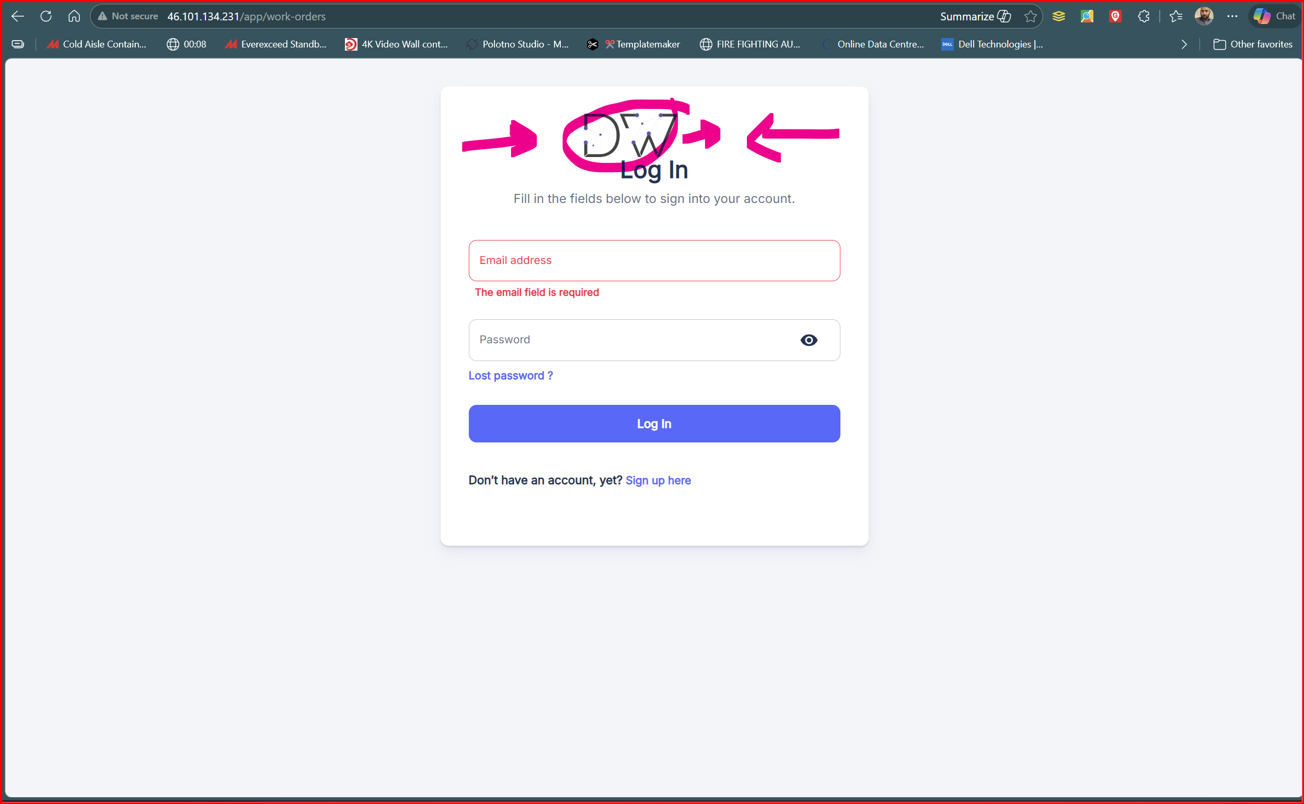

- Logo , name alignment for Sign up page , also when I make Sign up , there is no activation from Manager of the Software or something , or even to email sent to the email for activation purposes , it immediately allowed me to login to the system , which is wrong and not secured at all.
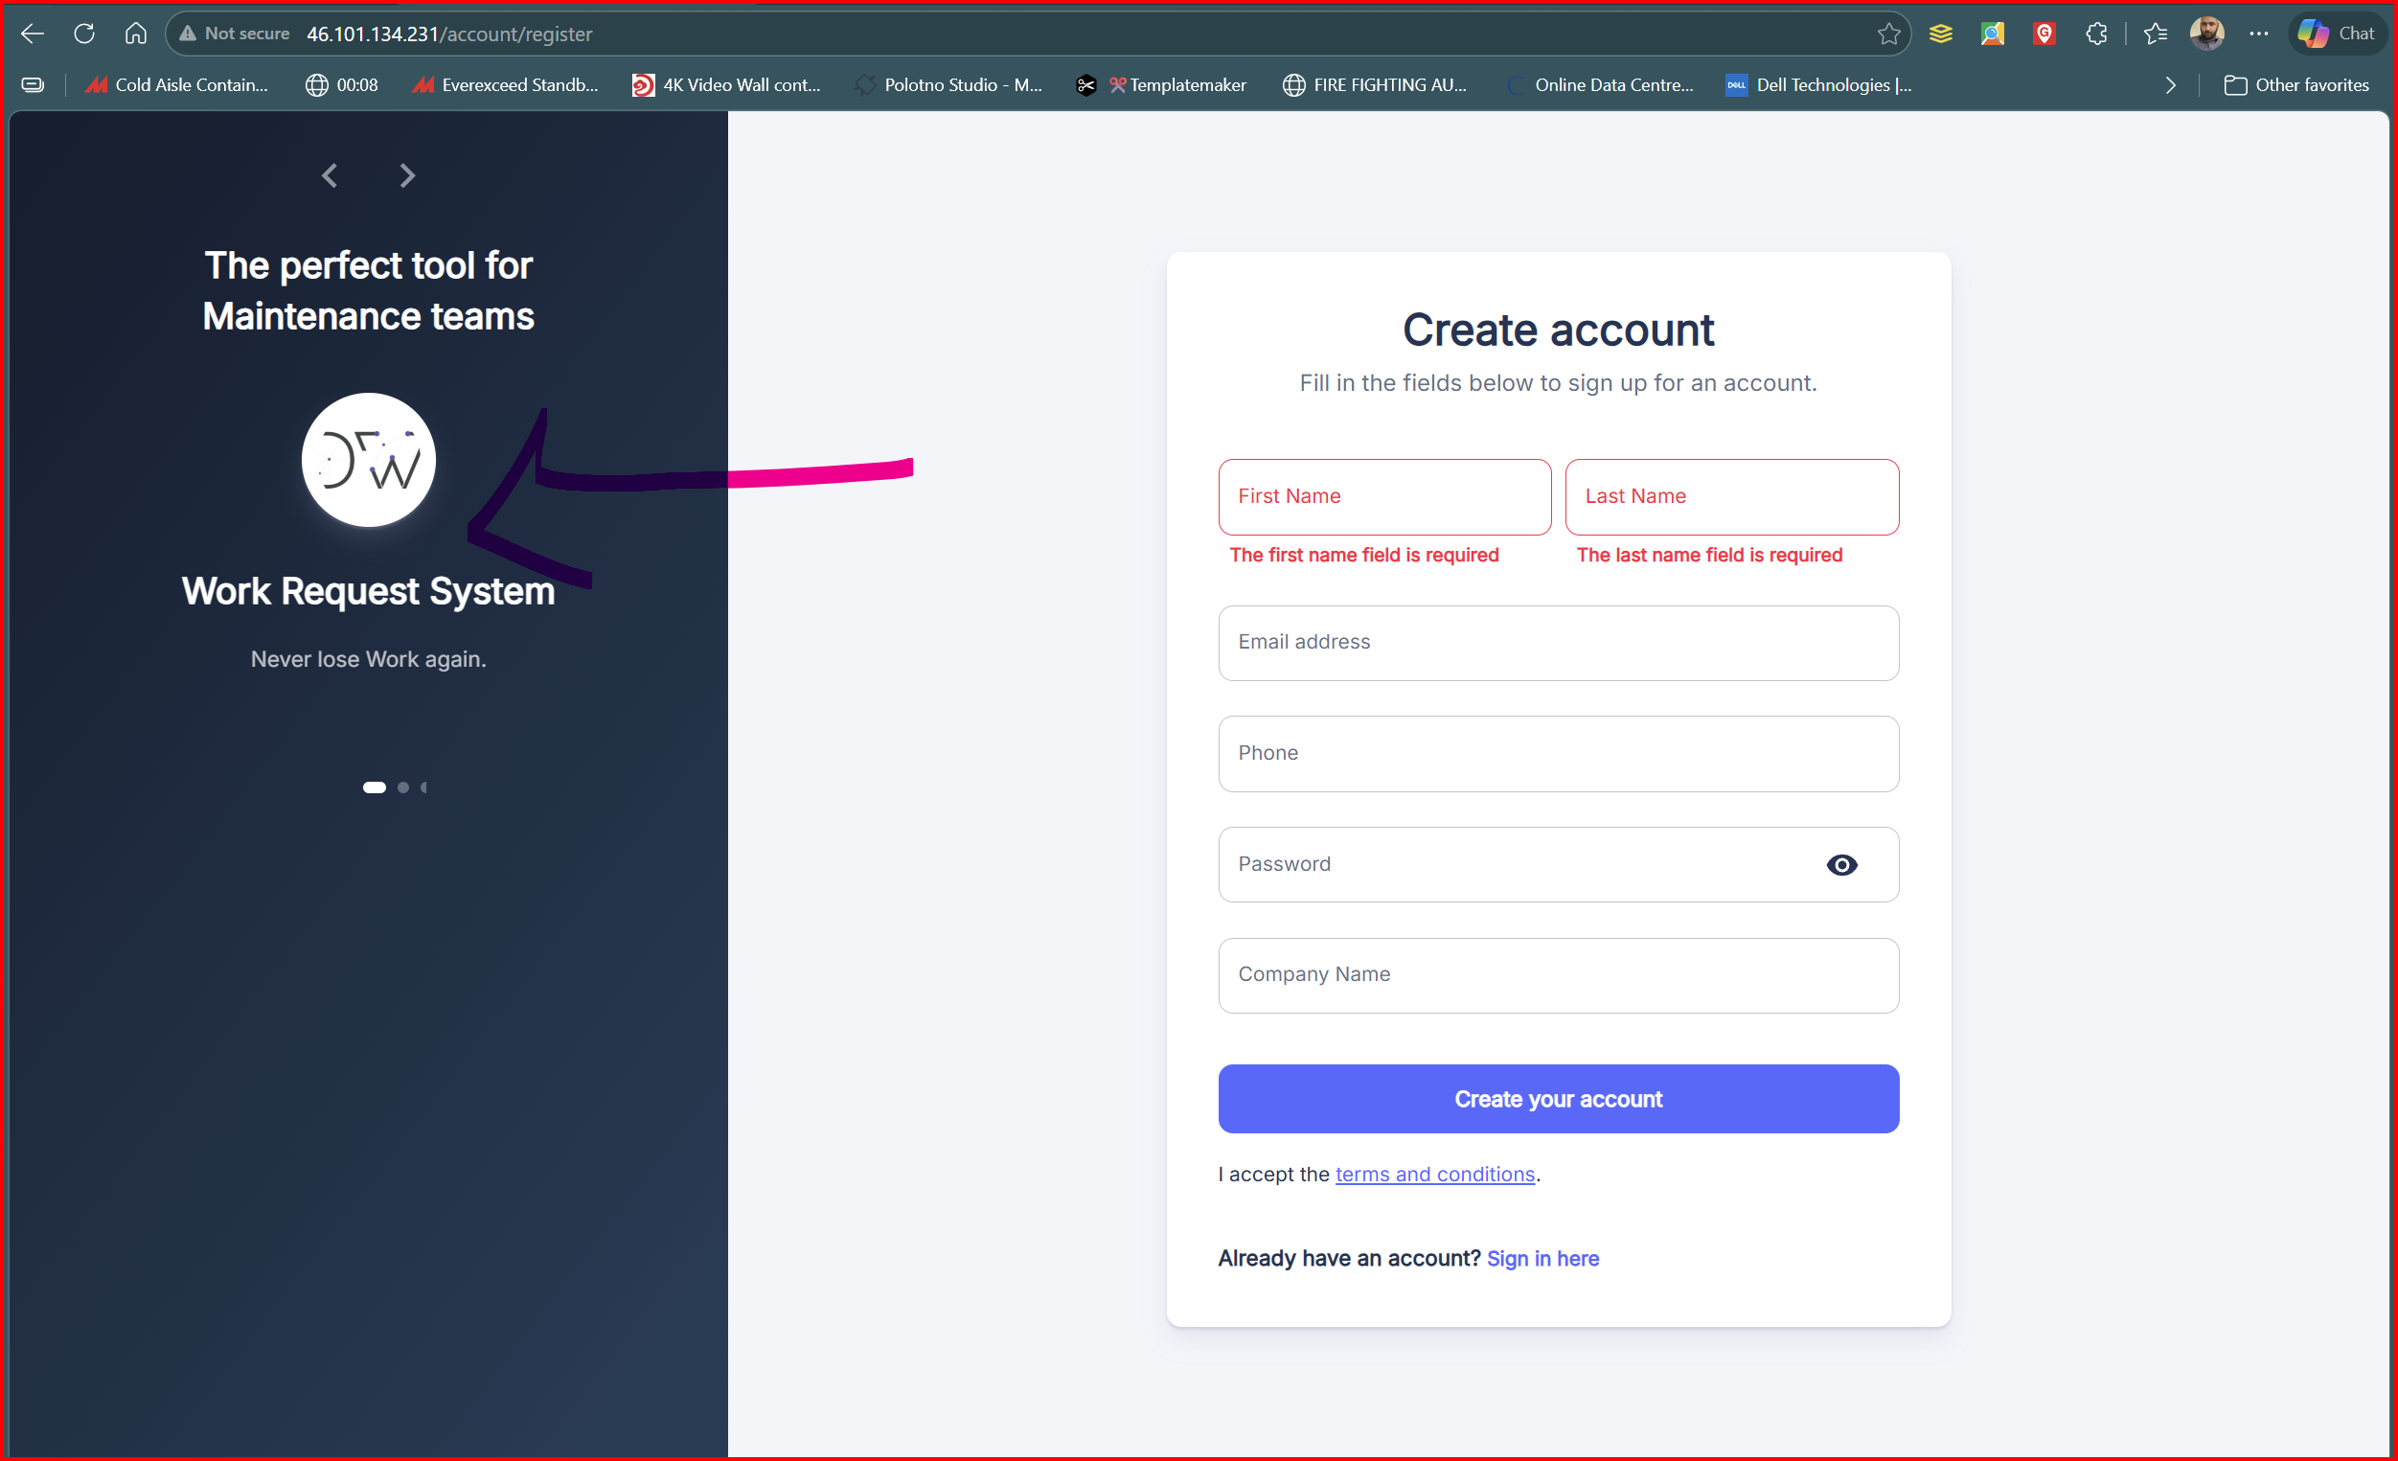

- Logo , name fix , alignment for the Dashboard page
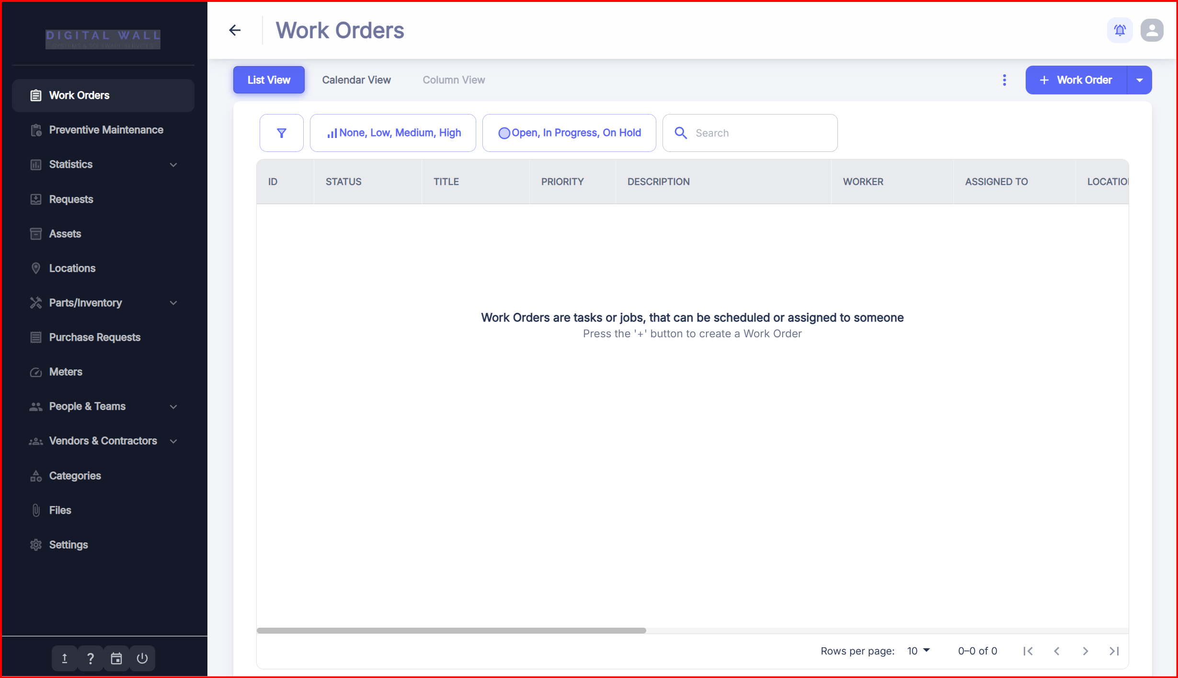

- When I point to the Logo , its saying Atlas CMMS , please fix this as well, also when click on the logo , it takes me to website ( rubbish )

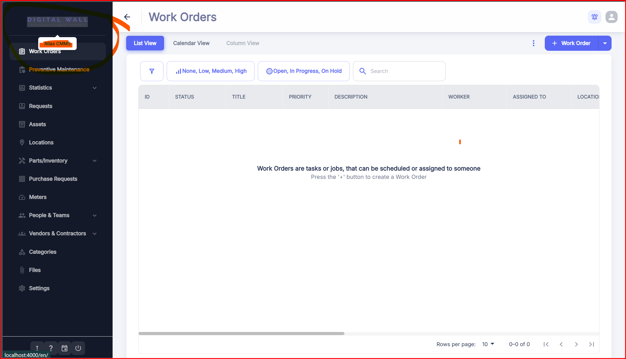

- Please remove this tab saying coming soon for the Column view page inside work orders

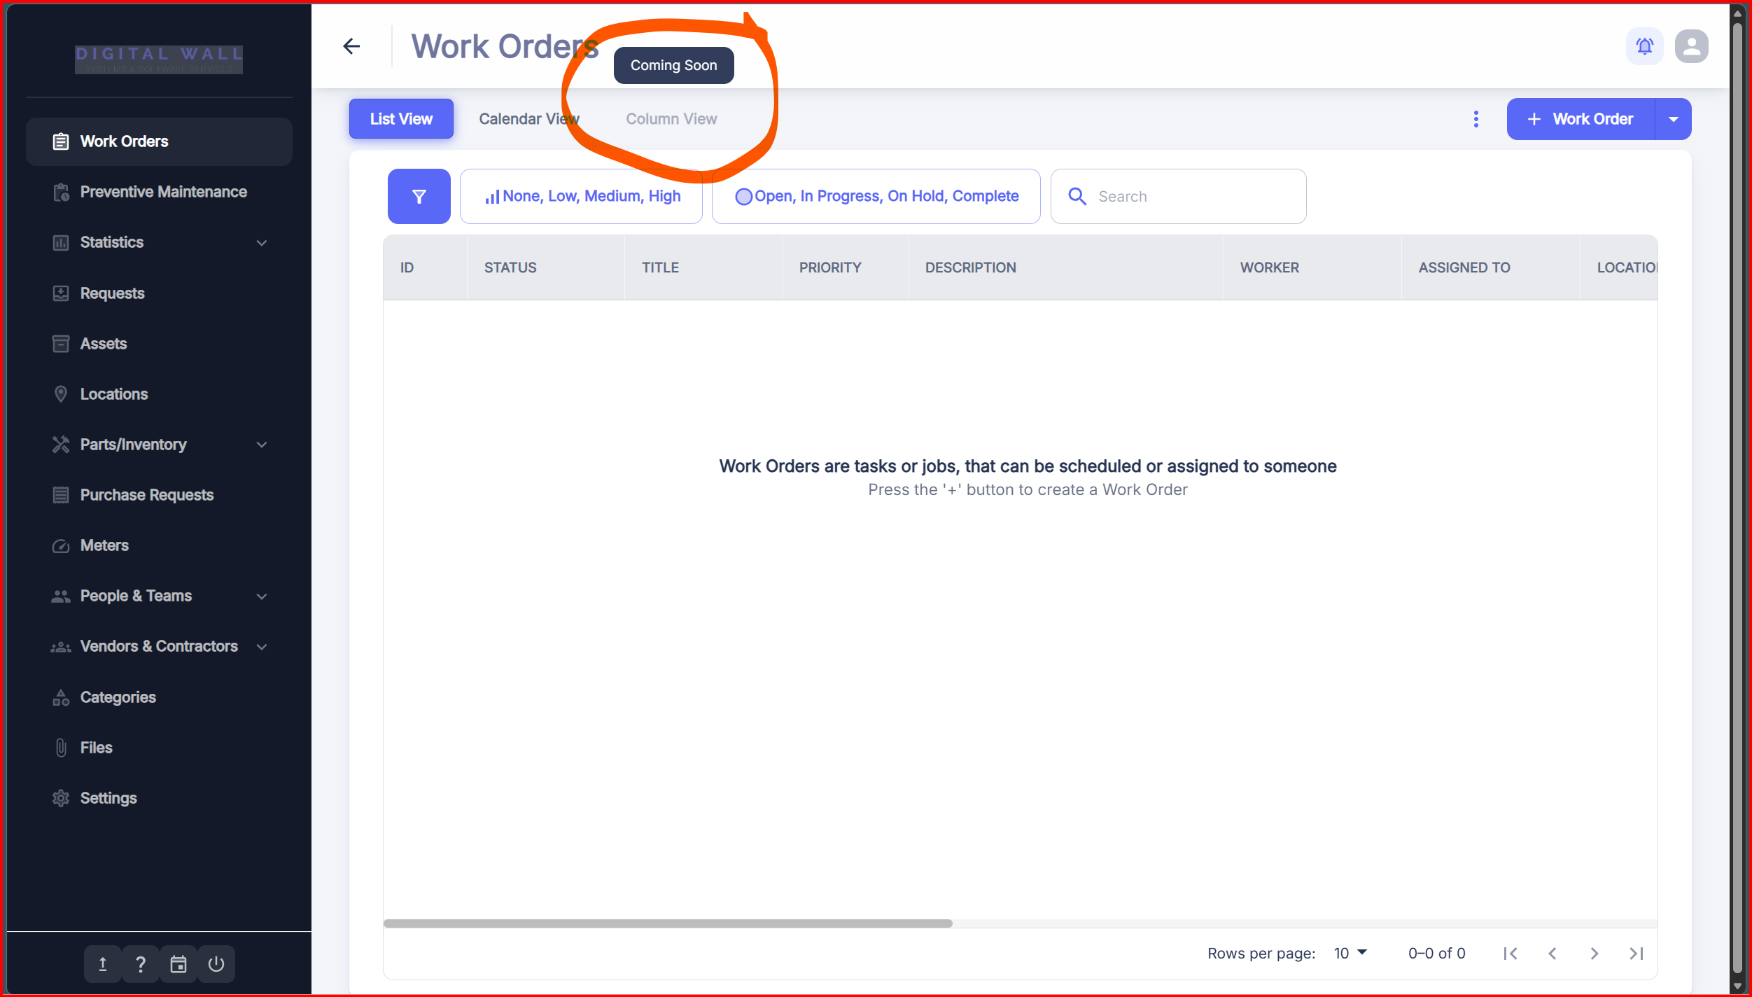

- Currently, when creating a Work Order, if a required entry (e.g., Category, Primary Worker, or Contractor) does not exist, the user must cancel the current form, navigate to a different settings module to add the data, and then restart the Work Order creation process.

I would like to request an "Add/Create New" option directly within these dropdown menus. If a user cannot find the specific data they need, they should be able to click a button (e.g., a "+" icon or a "Create New..." link) within the same window to add the missing information without losing their current progress on the Work Order

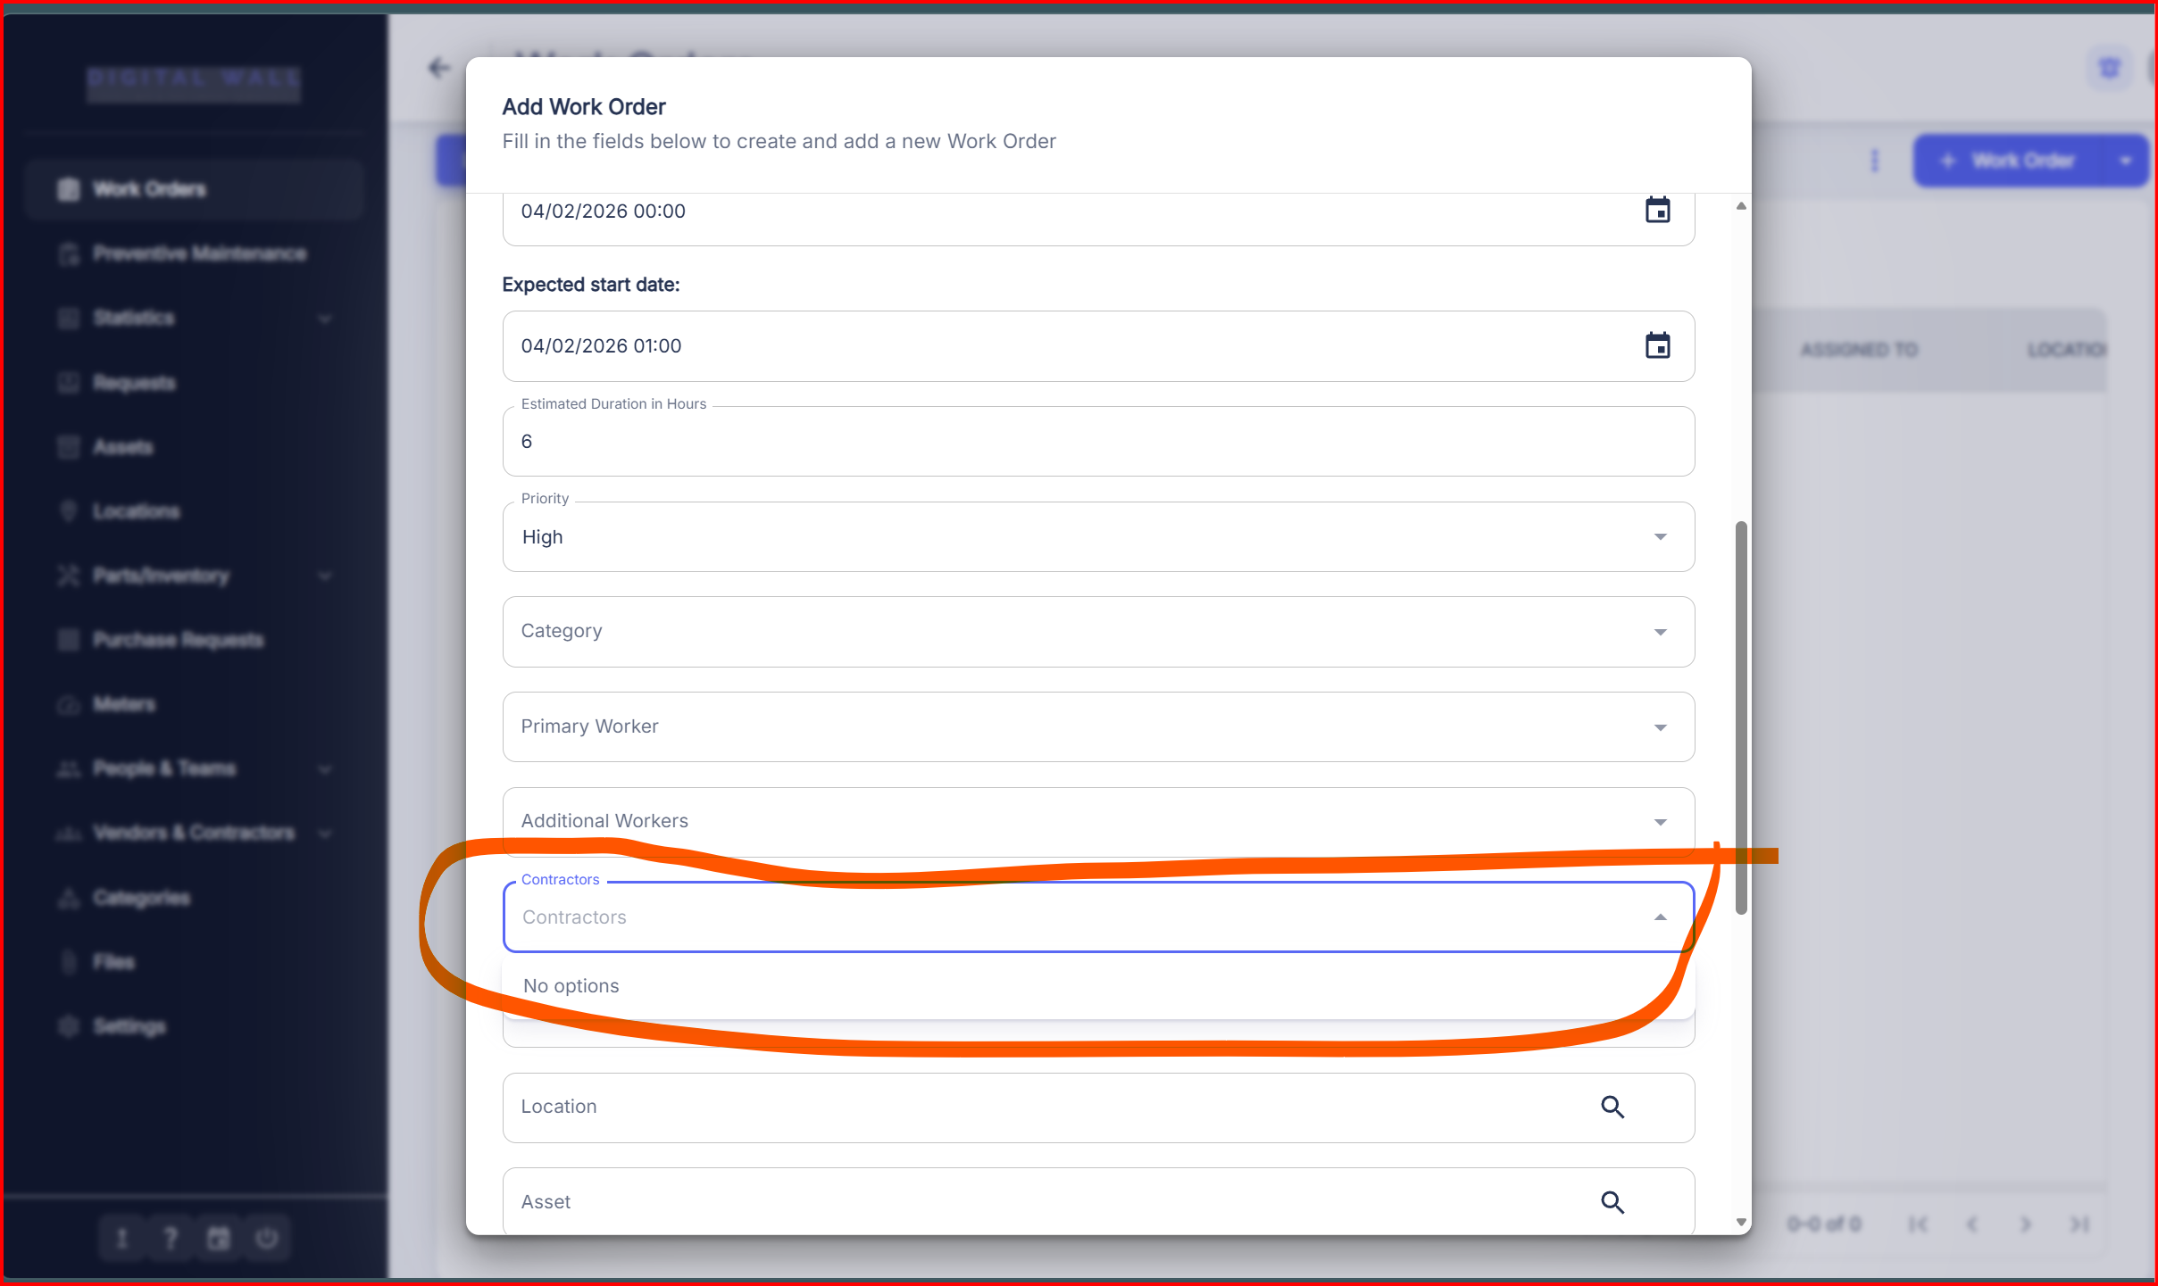

- When I created a word order , the system should send email to whom Work order created to notify him that you have new work order , eg. I created a work order for baqer or yousif , or you , the system should send you email based on ( your registered account in CMMS ) and send you that your work order is created, I will attach Example
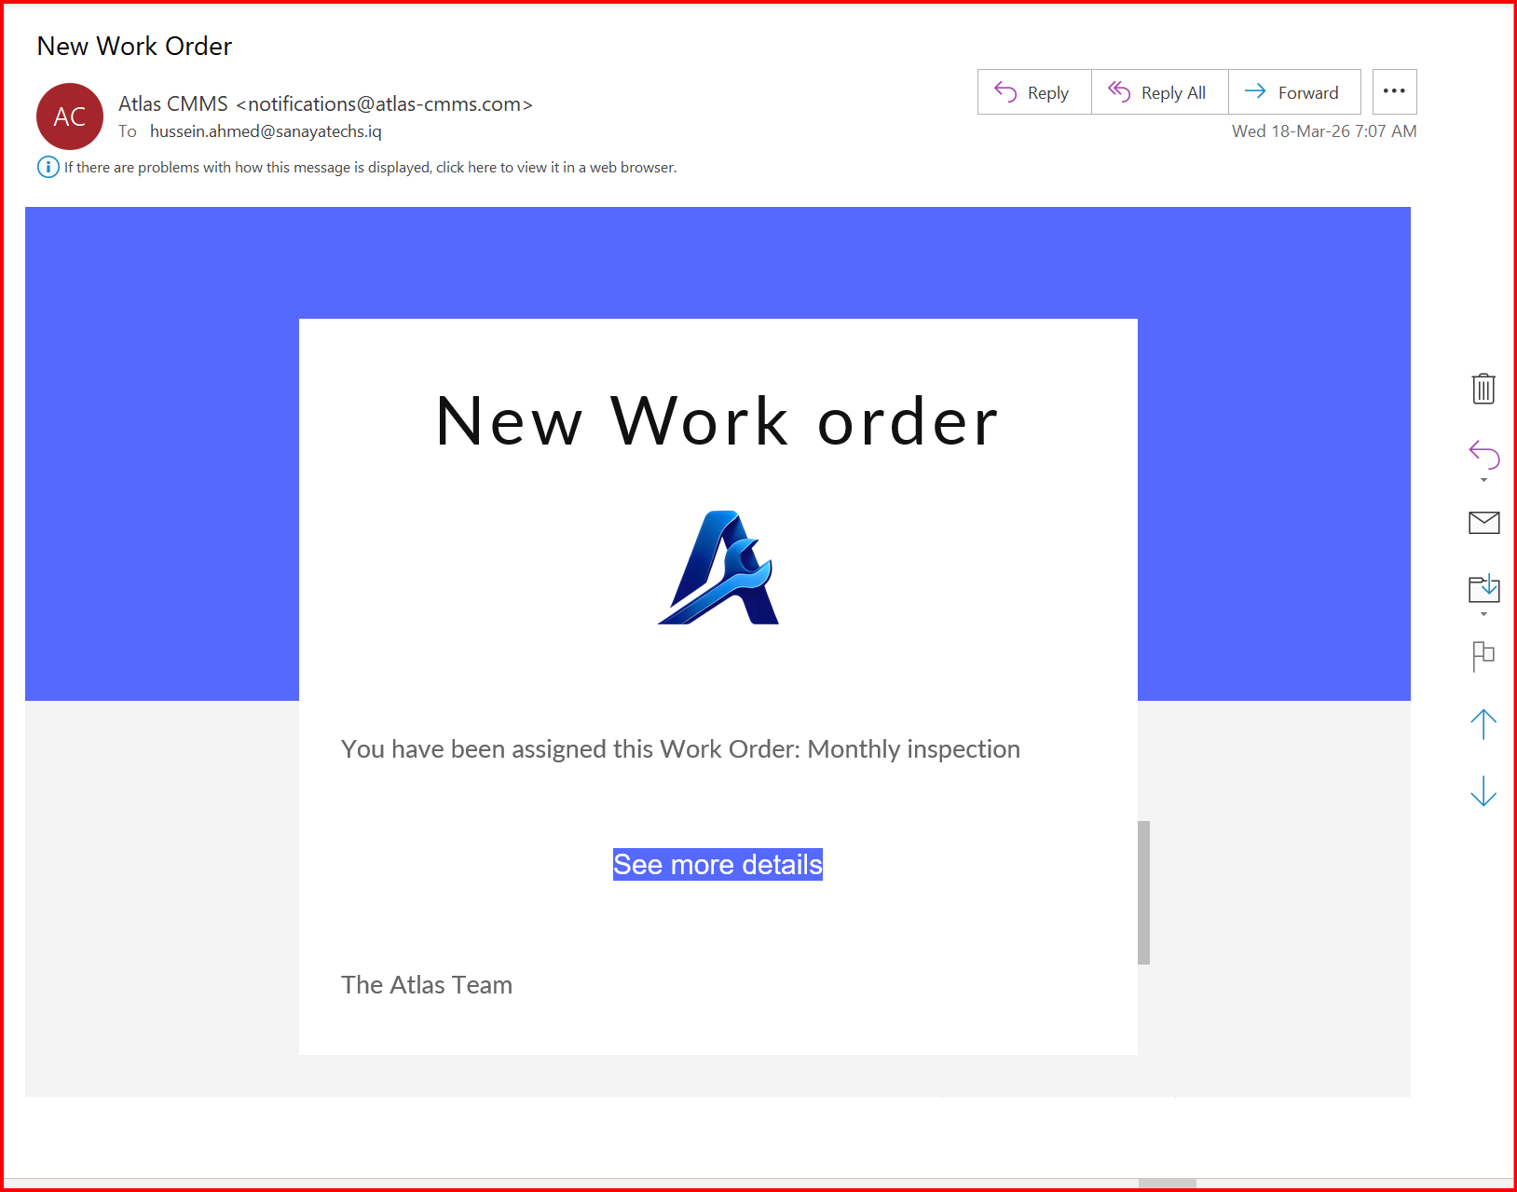

The email should come just like photo attached above , New Work order , you have been assigned this work order : bla bla bla , then ( click for more details or See more details , the system should take him to the CMMS system so he can view his Work order , and also at the footer it should appear the software name ( SyncShield ) with its logo , “ SyncShield Maintenance team.

- Remove the timer I don’t use it, remove the labour Time , Rate ( we don’t make Rate based on time or hours , we make payment for labour per day , so please change the Unit rate for labors from Hours to Daily , weekly , monthly , annualy)
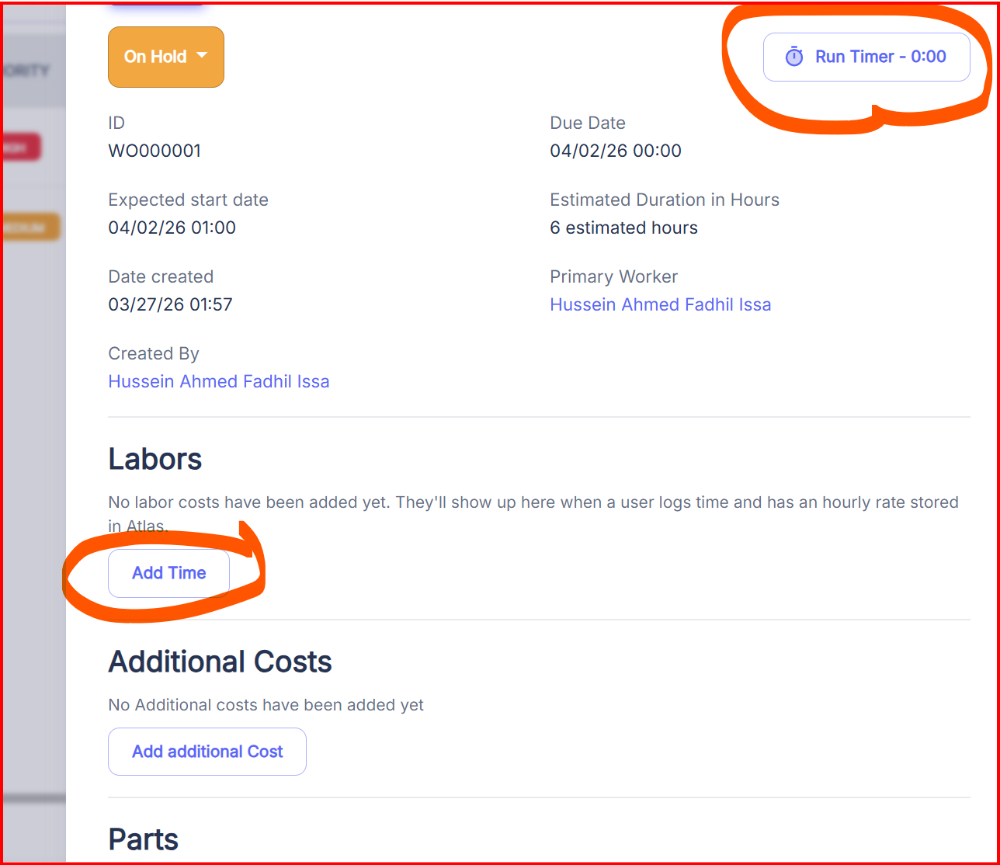

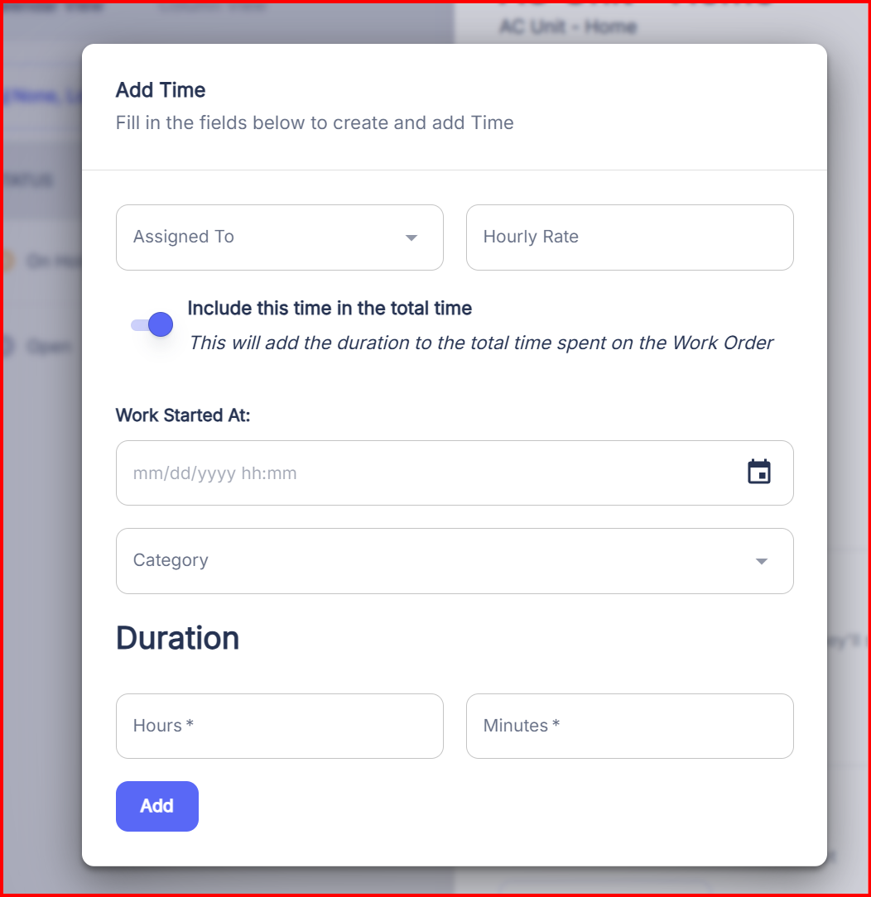

The Add time button , should align with Rates of ( Daily , weekly , Monthly , Annualy ) so no hour rate , it will be :
- Assigned to ( ok )
- Hourly rate ( not hour , but a selection either day , week , month , year )
- Include in total time ( remove it )
- Work started ( start Date , without hours )
- Category ( ok )
- Duration ( not hours , minutes but days, week , month ,year ).

- When I click on updates , it say a license is needed to see work order history , please fix this
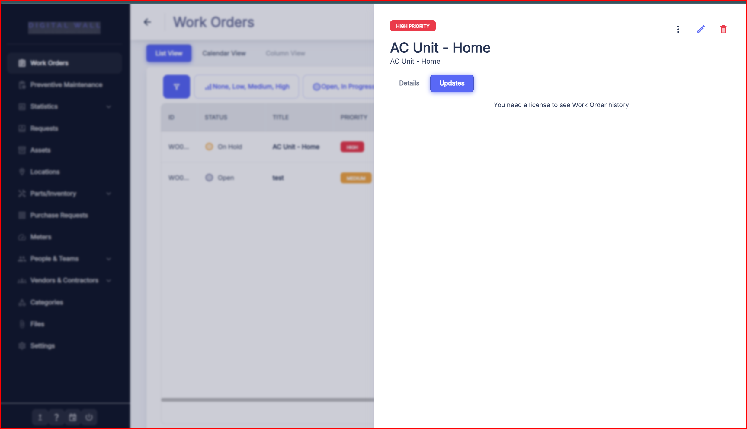

- Work order Report Generation , I prefer it should support Word Document also , not PDF only
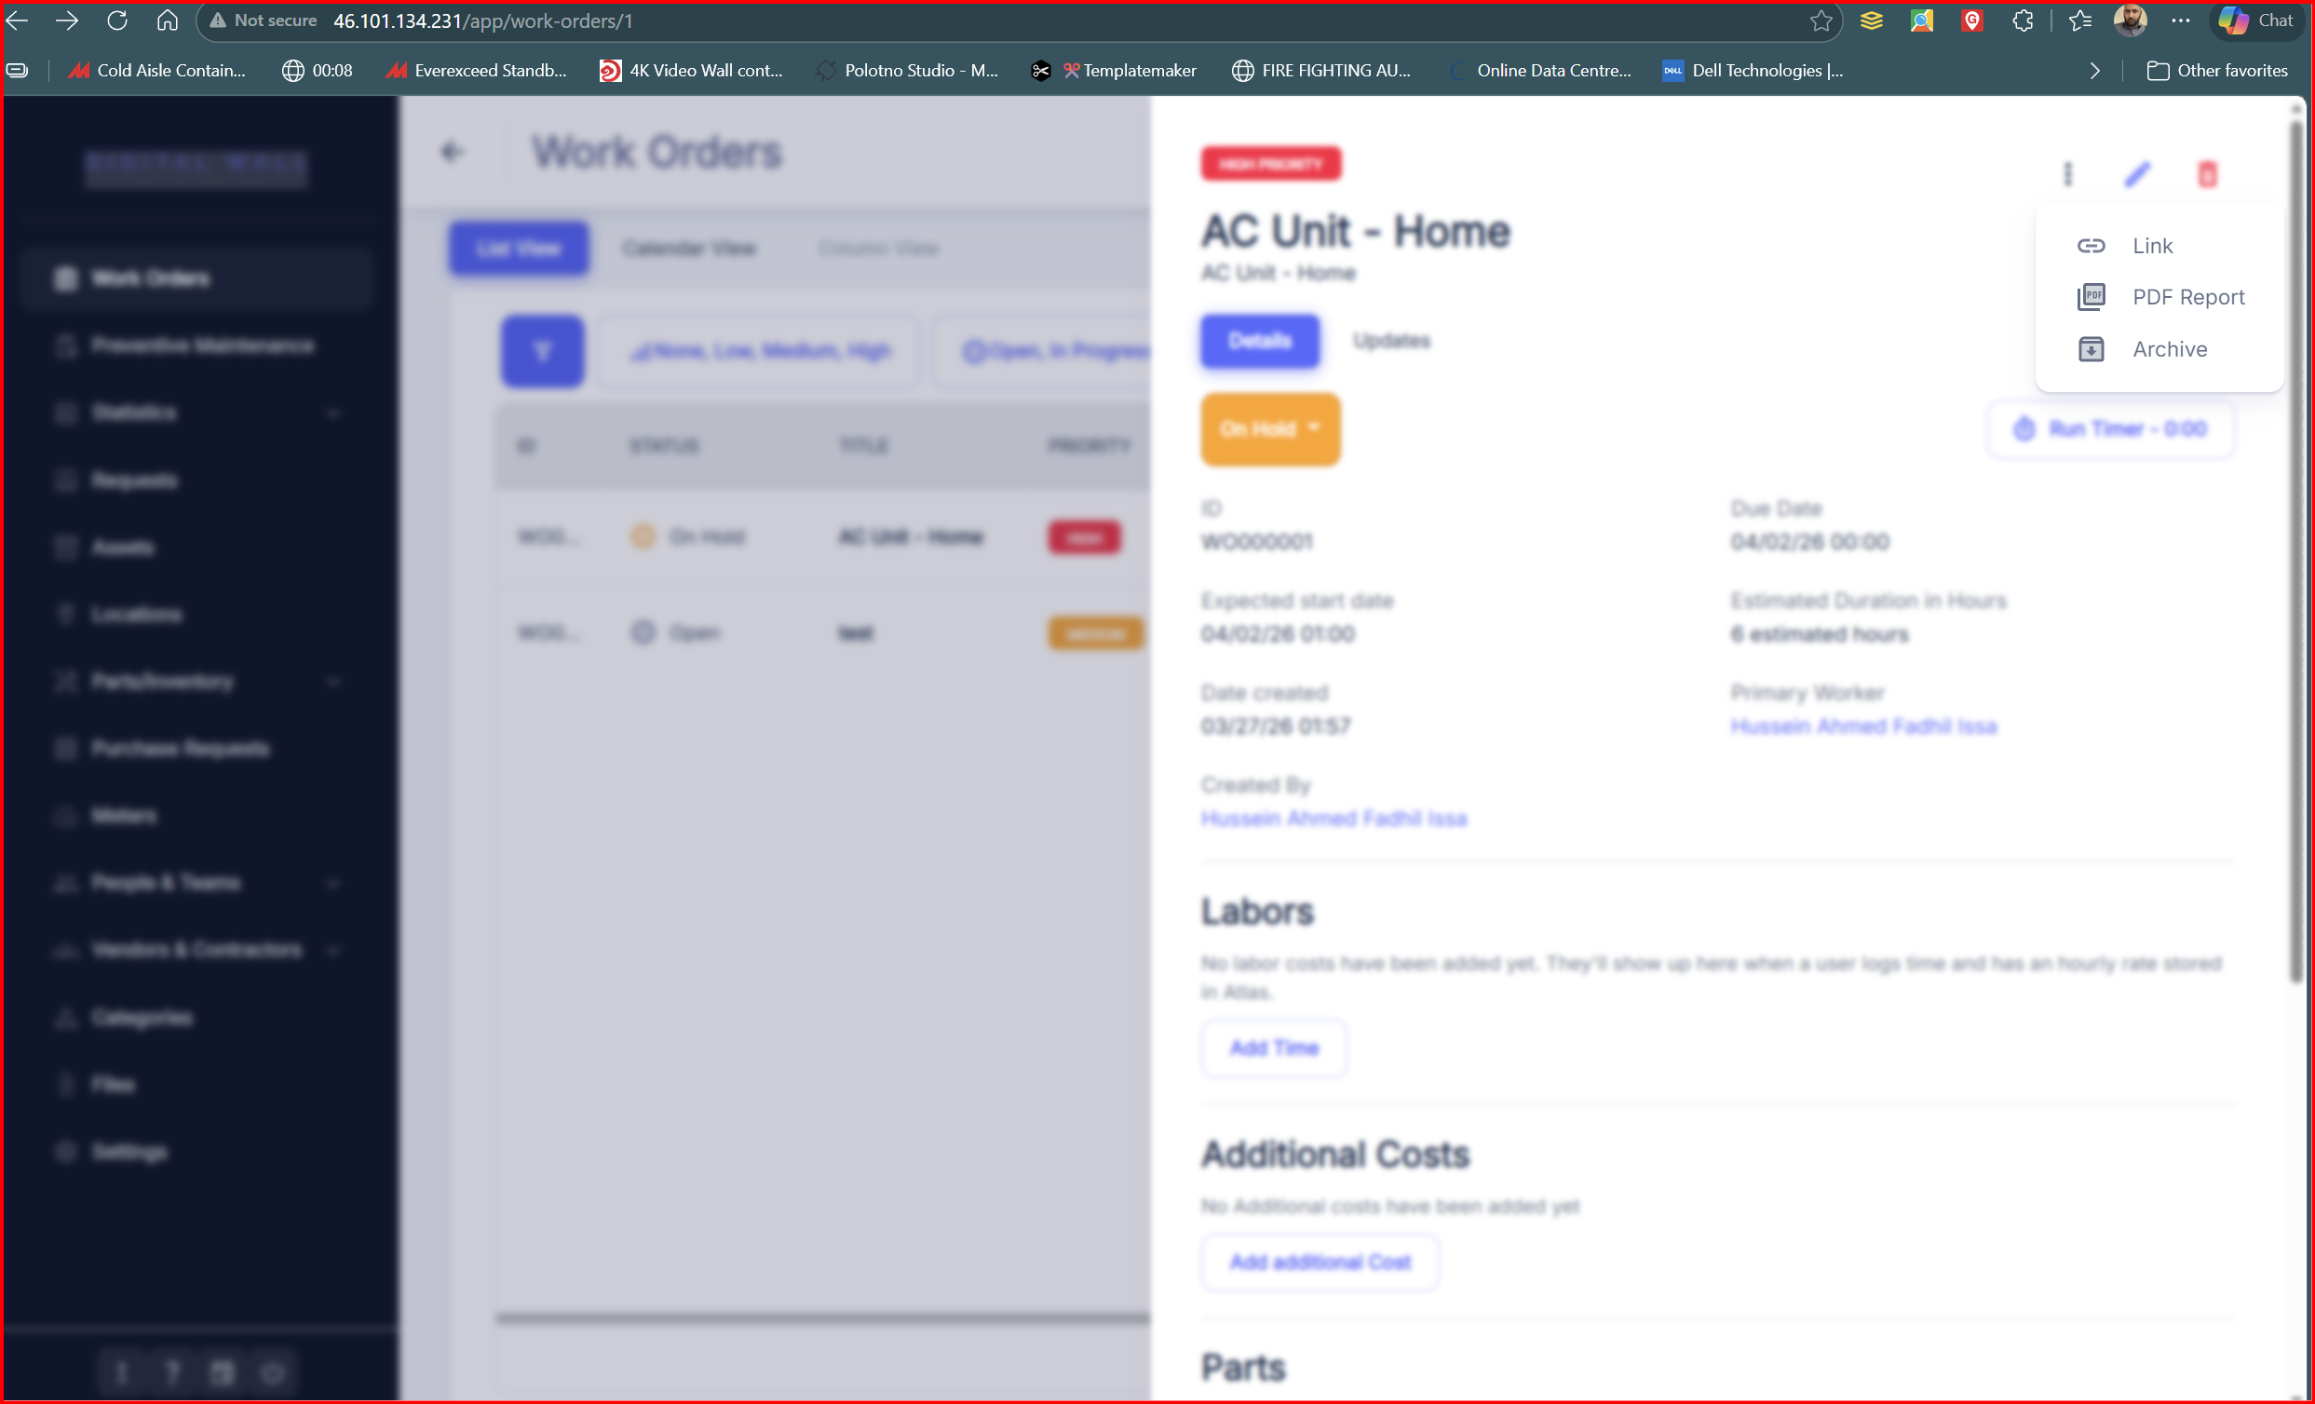

- When I click on PDF report , the work order appears in this way , please refer to the Work document I will provide you , we need the Work order to be designed in that way , also put the new software name ( SyncShield ) , also the Generated File name of PDF , Word Doument of Work Order should be named As follows ( SyncShield_WO### ) based on Work Order Number created in system.
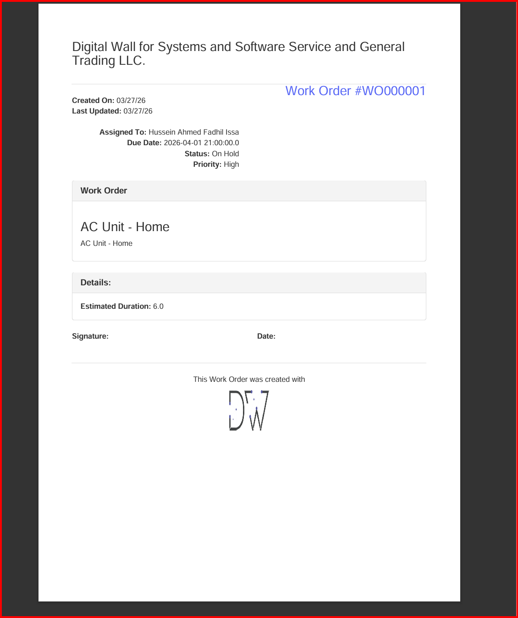

- Preventive Maintenance tab :
When create preventive maintenance , also consider point 6 above , creating an immediate option during drop down list. , also send the trigger to the

Also there is no Generate PDF report for Preventive maintenance , or export to Excel as well , please add it , ( use the template of Work order to generate the Preventive maintenance Matrix

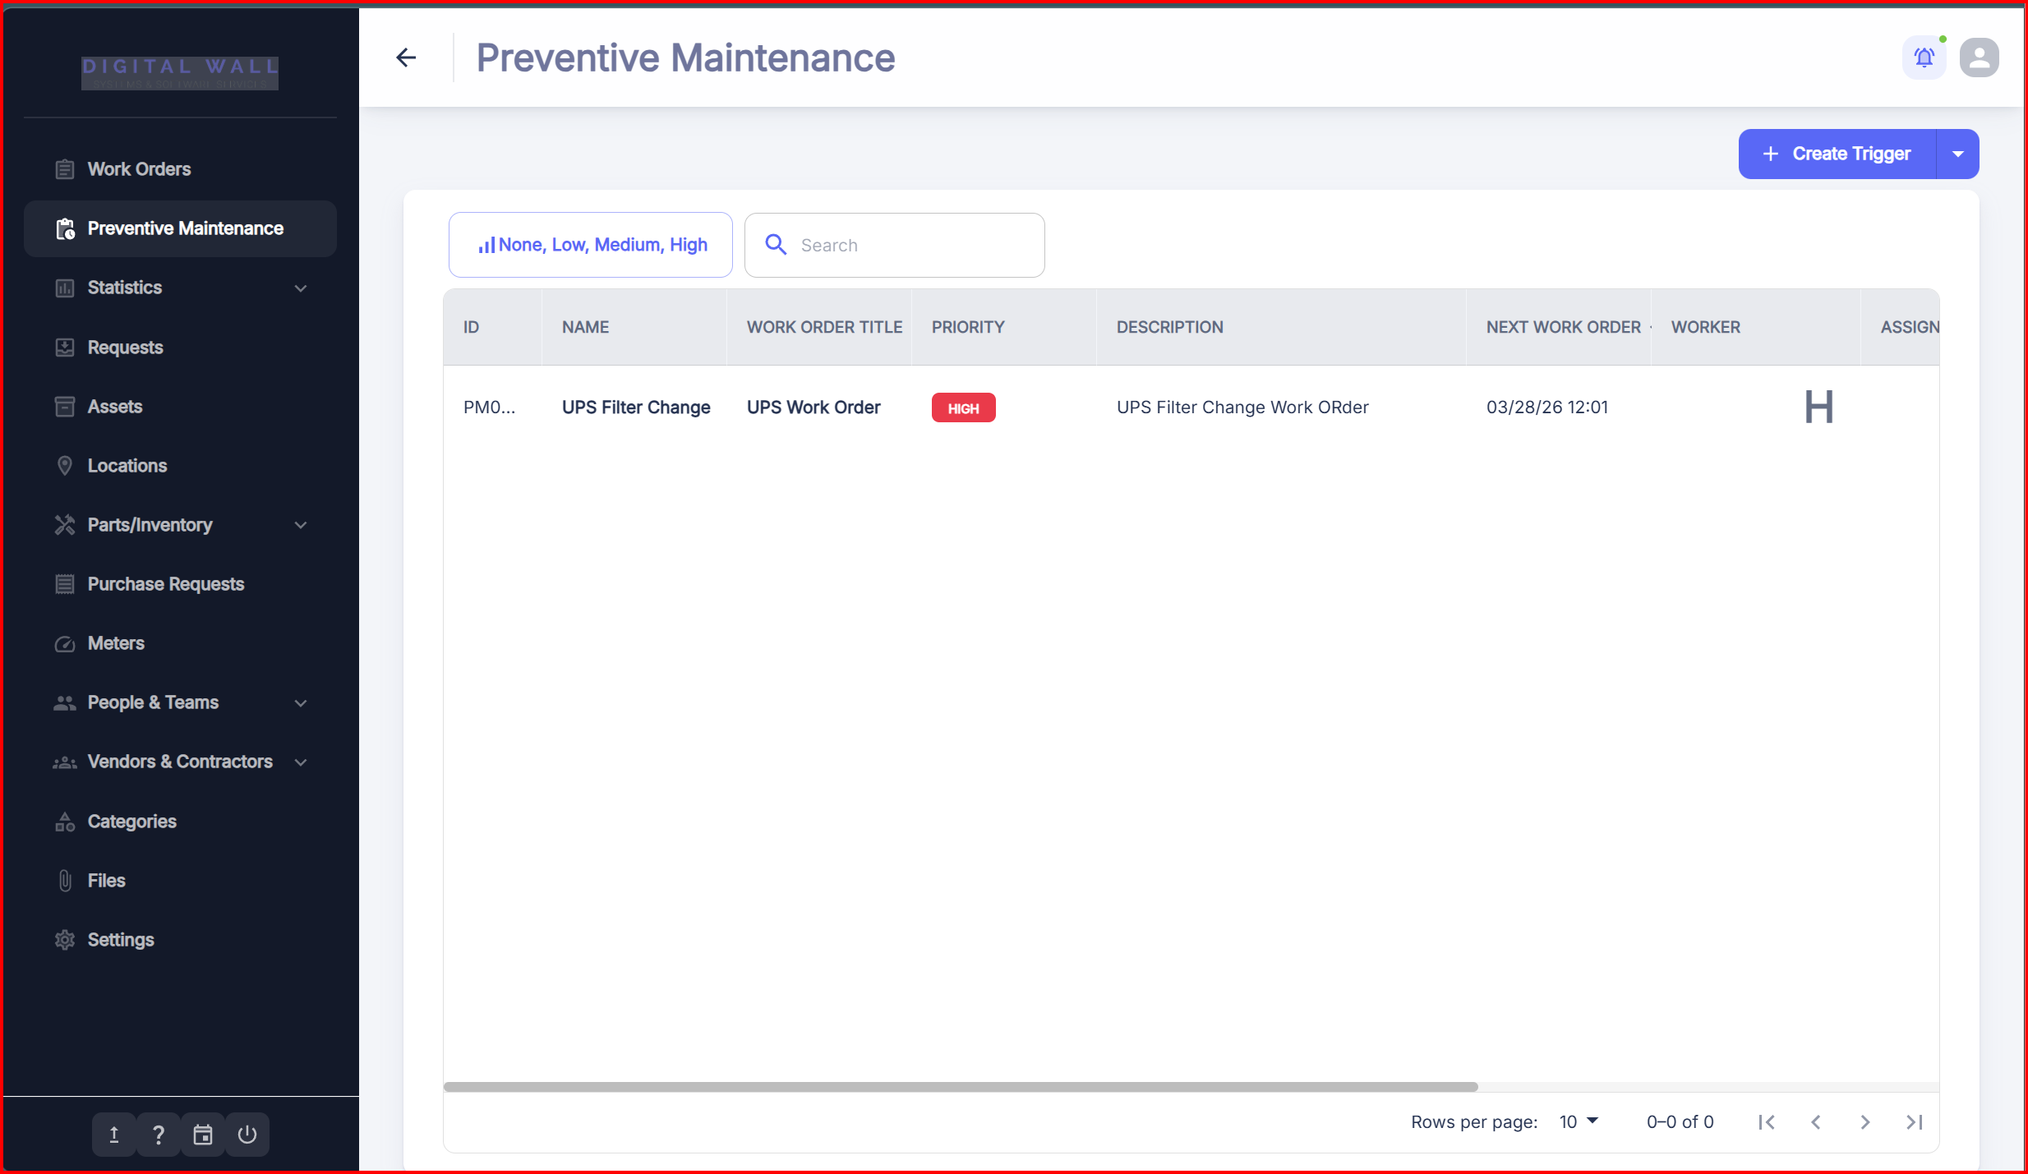

- System Statistics : please change it and rename it to ( reports ) please find below image
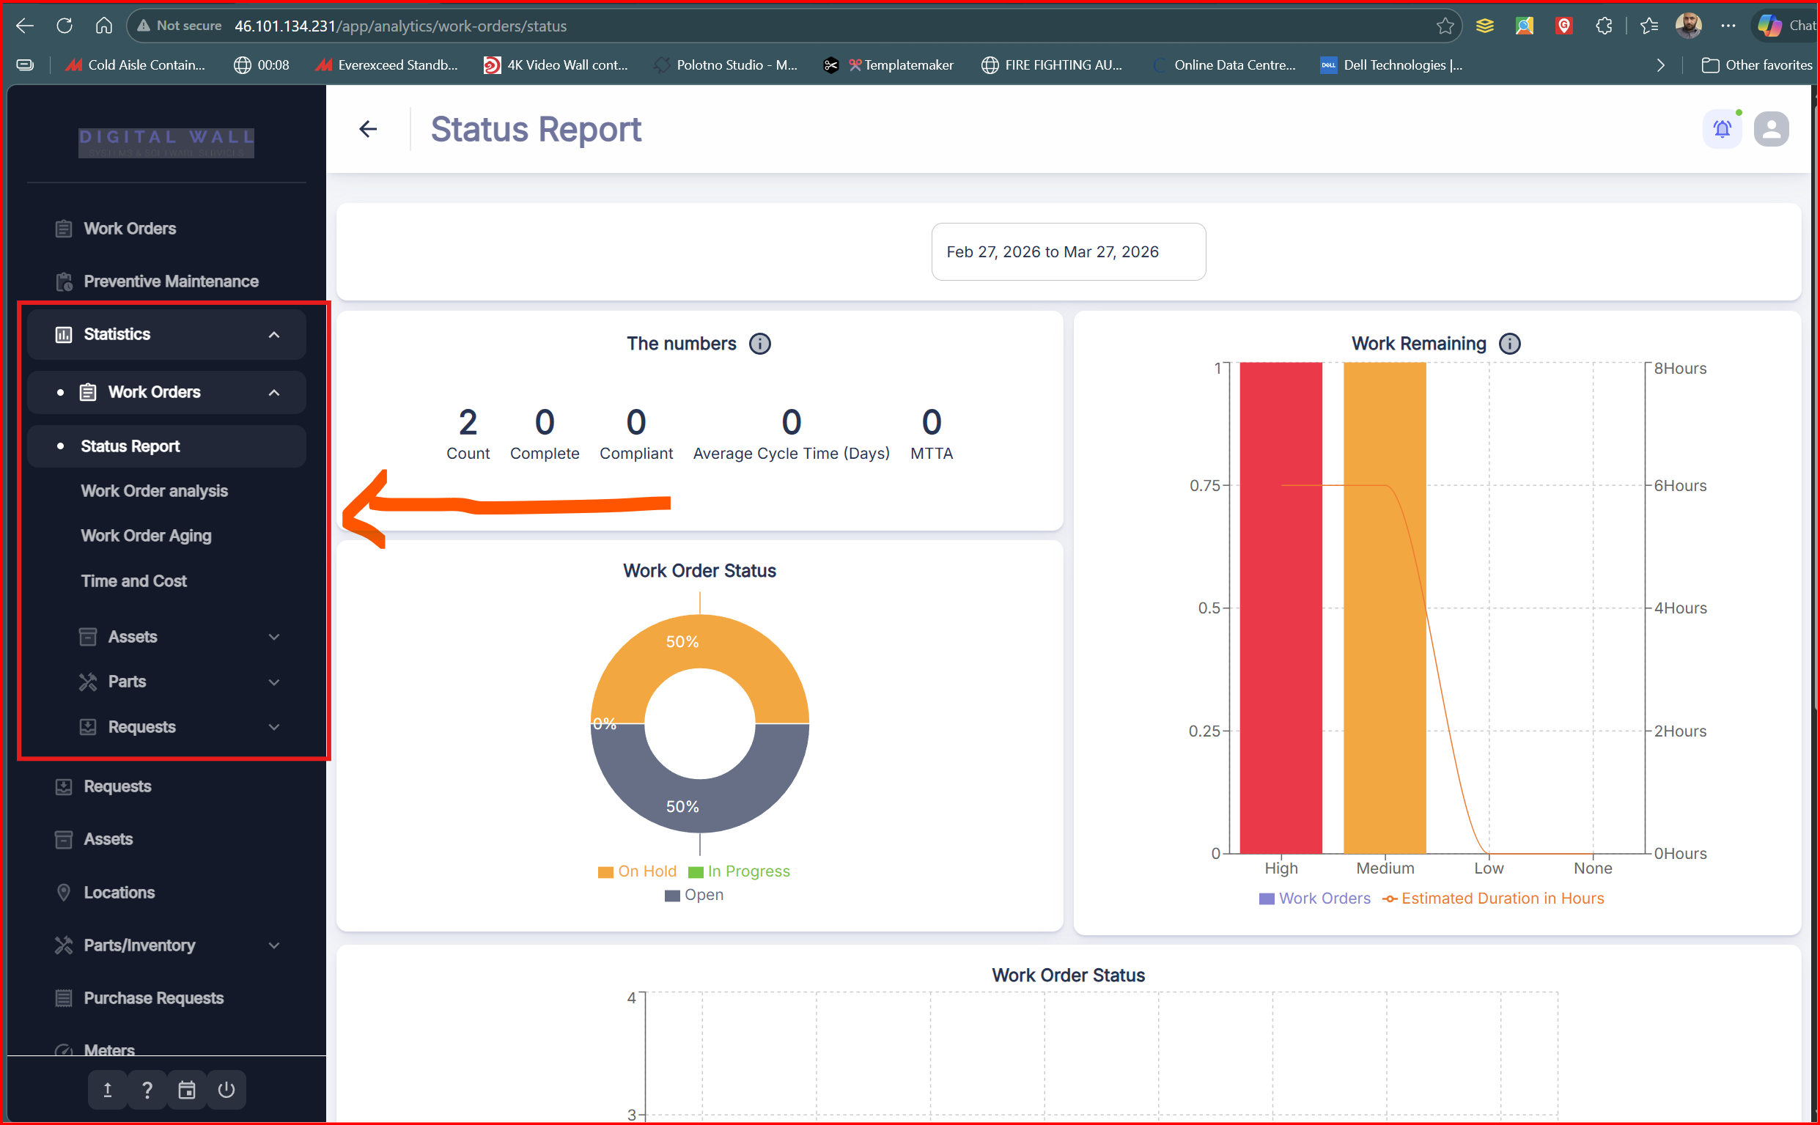

- Status Report ( I need it )
- Work Order analysis ( I don’t need it , you can remove it )
- Work order aging ( I don’t need it , you can remove it )
- Time and Cost ( I need only Cost , I don’t need time , maybe dates is ok , but not time )

Status reports :

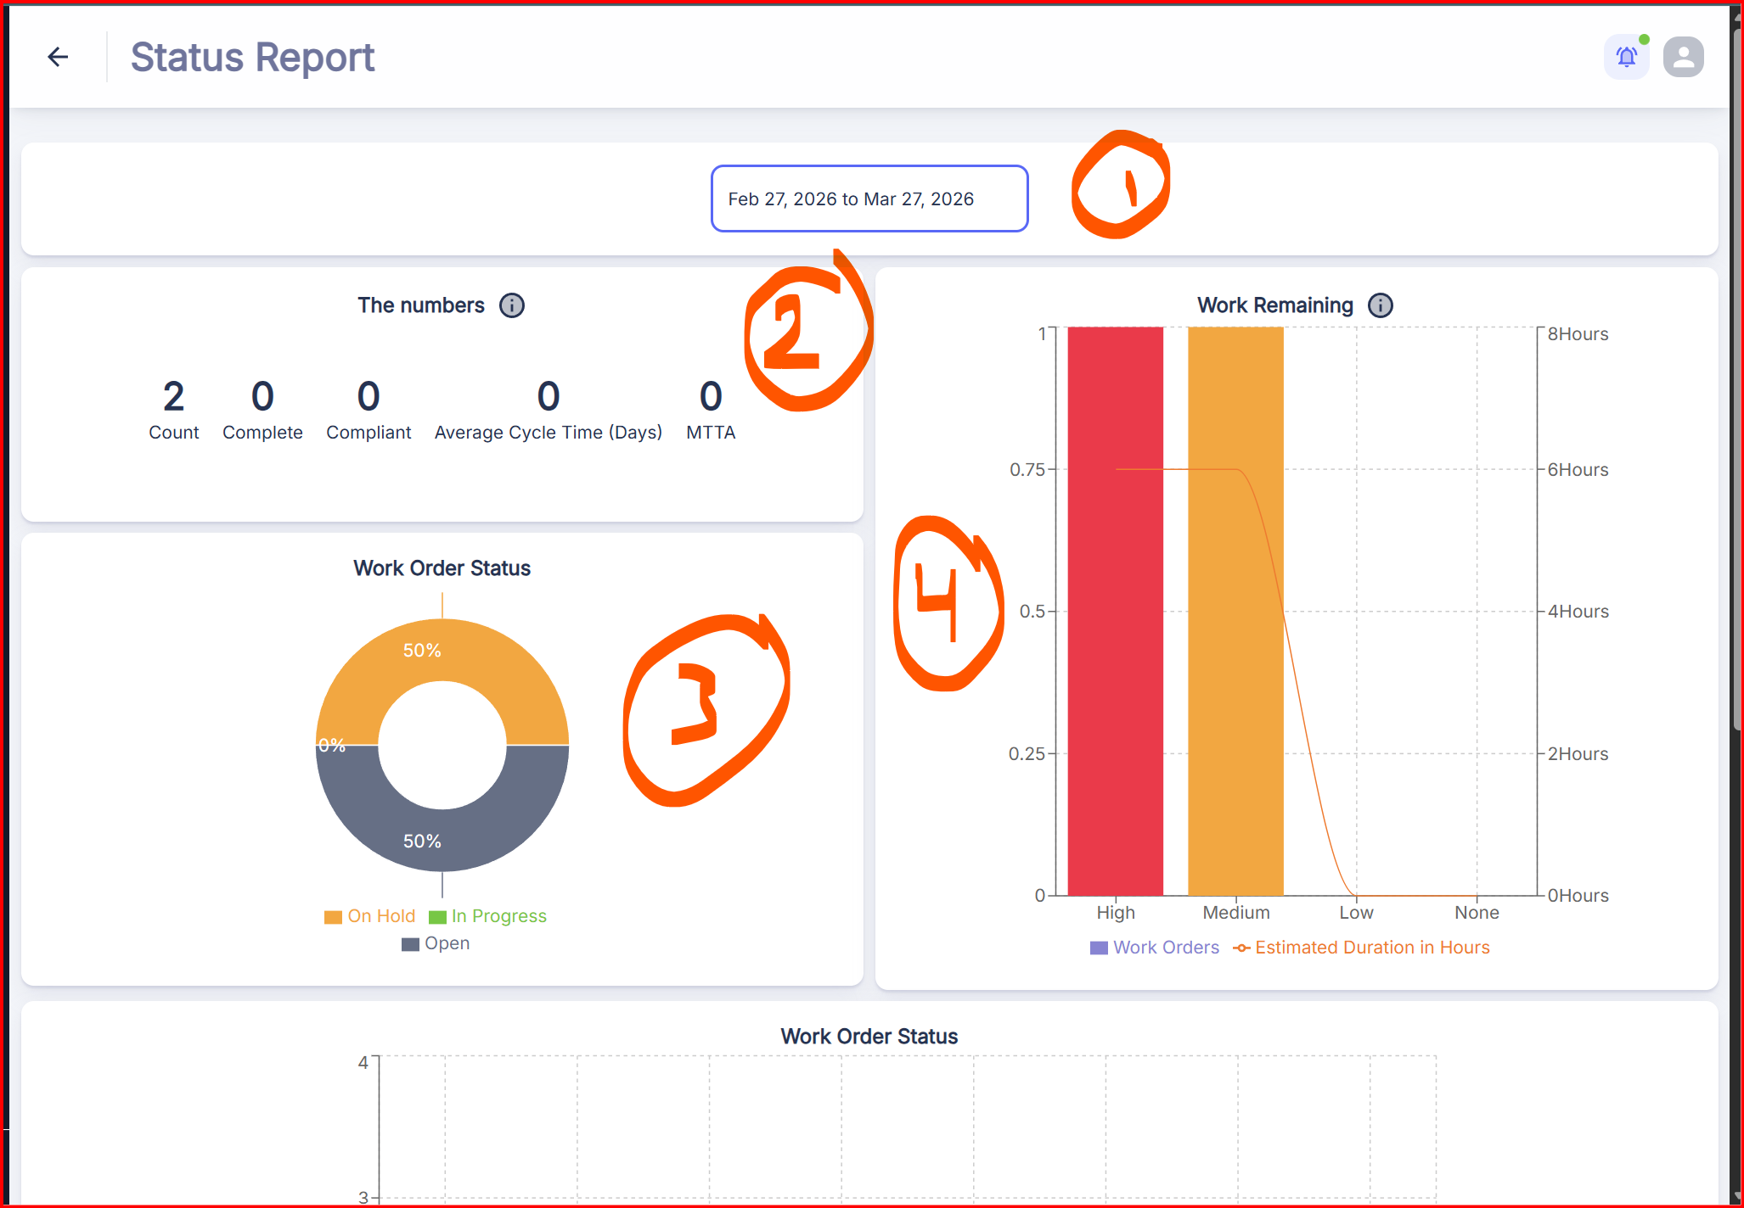
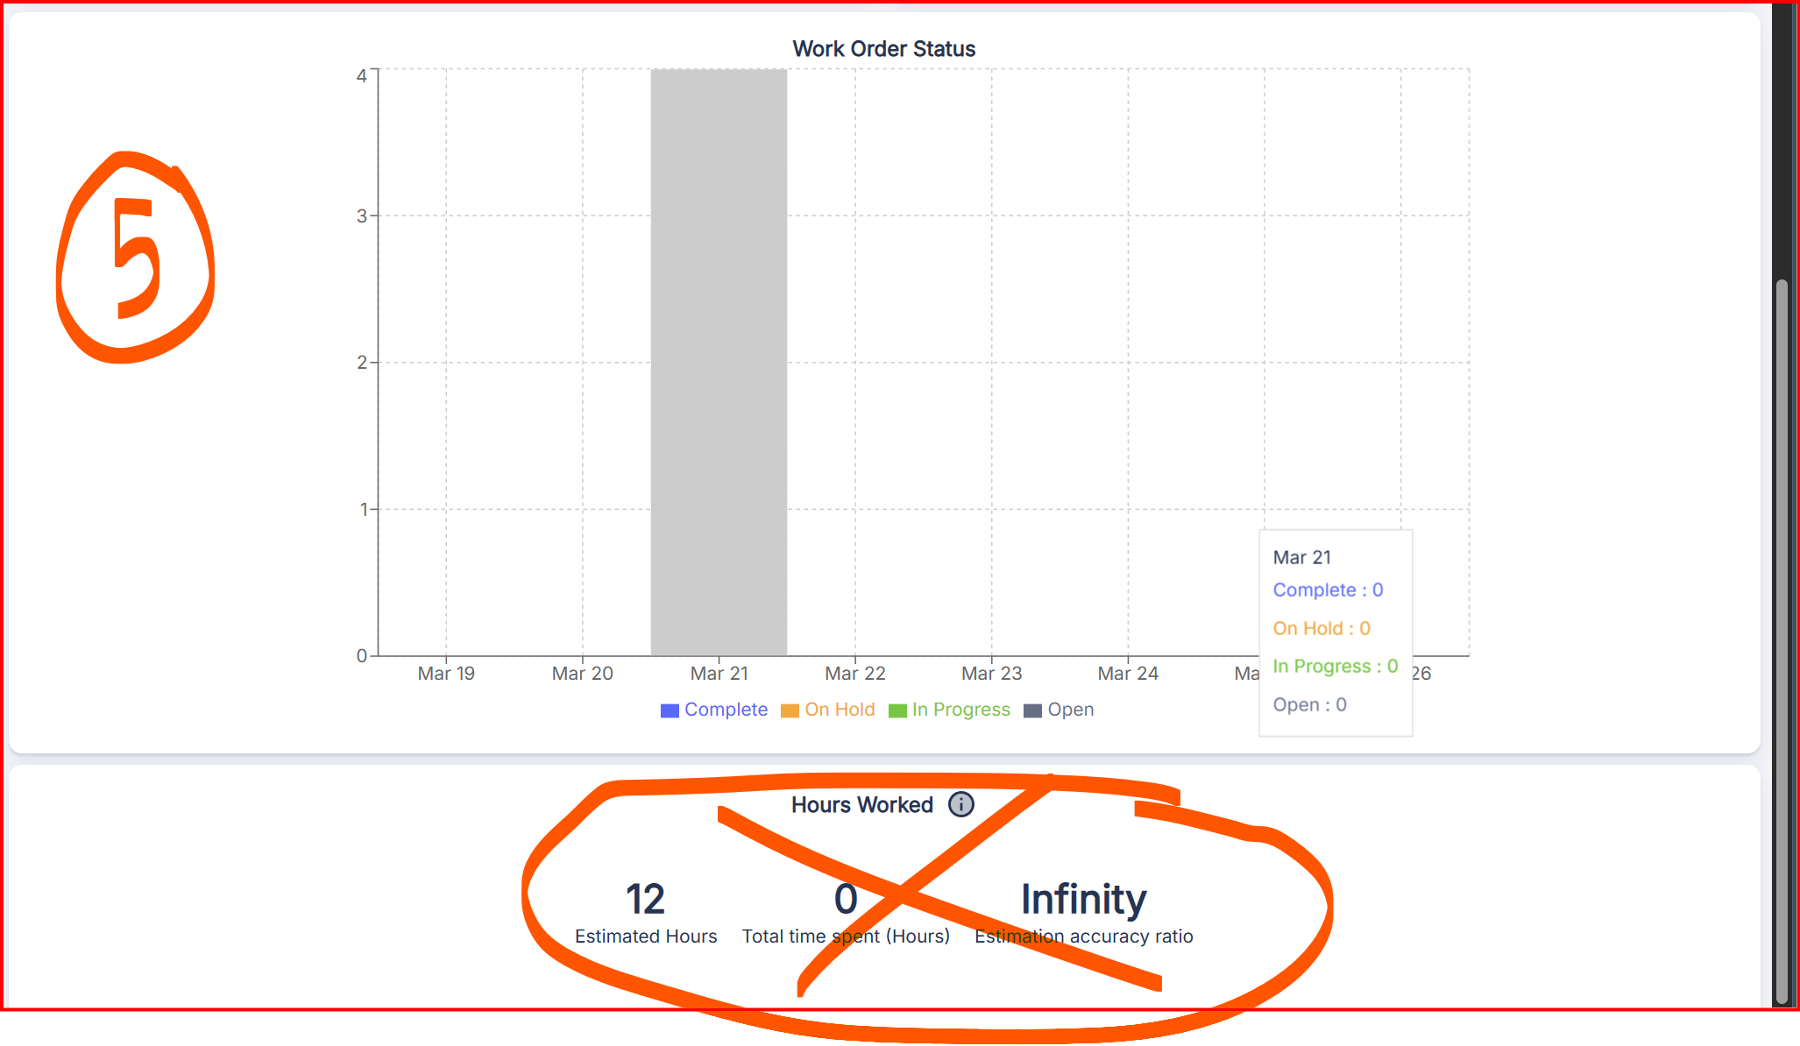
The Date ( number one 1 ) is good and nice I need it , it allows me to choose the date so I can view the status report , but make the button nice , it takes all way the row of the page , you can make it better ( align it better way )
The numbers & Counting ( Number two 2 ) is good and nice , it allows me to View the number of Counts , completed , remove the compliant , remove the average cycle time ( days ) and remove MTTA and replace with ( Count , Complete , on Hold , on Progress , Canceled ) so I can have better view to what is completed ,what is on progress , what’s canceled , and when I click each it sends me immediately to the proper page.

Number 3 ( Work Order Status ) , you can remove it , because I already requested it above ( number 2 )

Number 4 ( you can remove it , because I already requested It above) ( number 2 )

Number 5 ( you can remove it , because I already requested it above ( number 2)

Make all necessary changes , so it looks better , the Donuts bars , poll bars , etc.. but make it nice

- Please add export , I need to export that Report Status , not just viewing it in the website ,

- Time and Cost
Kindly remove anything related to time , ( name it Cost Report )
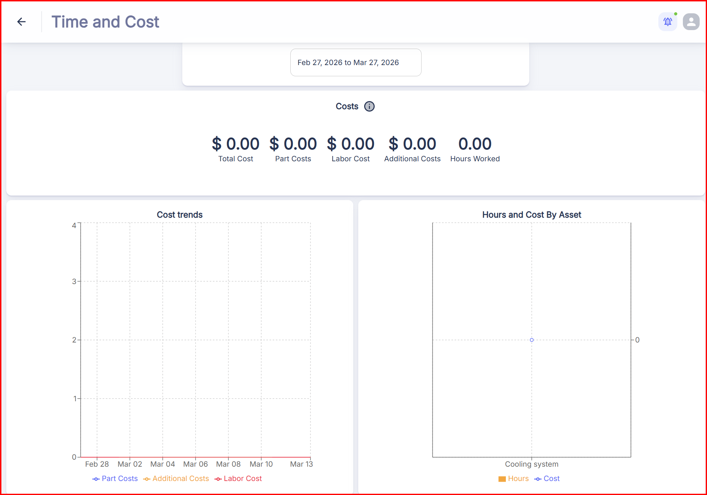

The Date Selection ( is good ) but as I mentioned in point 13 , make it better its taking all way the Row of page
Total Cost ( is good , I need it )
Parts Cost ( is good , I need it )
Labor Cost ( is good I need it , but change from hourly counting rates , to day , week , month , year , in configuration as I mentioned previously ,
Additional Cost ( good , I need it )
Hours Worked ( remove it ) I don’t want it

The Cost Trend Poll Chart , and Hours and Cost by Asset Poll Chart change it to align the above parameters of Cost ( make it donuts or even keep it but make it align to what changes I requested.

- Please add export , I need to export that Cost Report , not just viewing it in the website ,

- Remove these options in reports I don’t need it
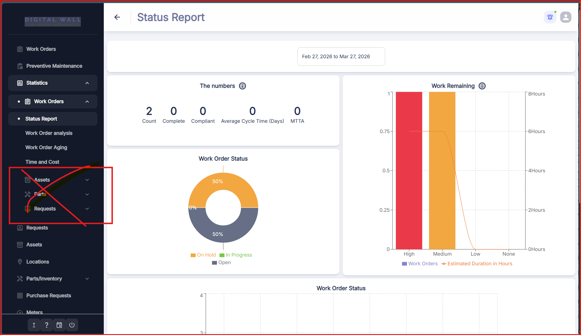

- The Requests : The Request feature is for users who do not have the authority to create a "Work Order" directly. Think of it as an "Inbox" for maintenance.
Who uses it: Office staff, machine operators, or tenants.
What it does: It allows someone to report a problem (e.g., "The AC is leaking" or "Server Rack 4 is overheating") without needing to know technical details or scheduling.

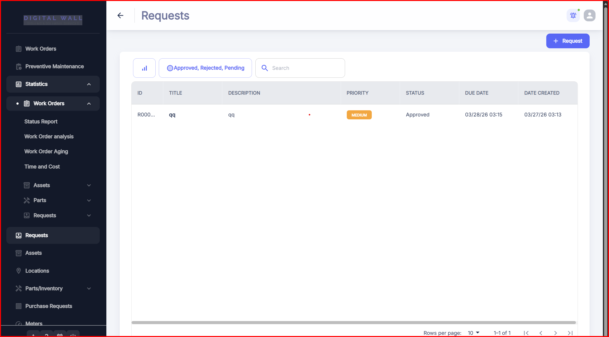
Based on information I provided for you ,find a way we can benefit of this feature and how to use it with clients , how can client make a request and it appears immediately to us in the system ( note , when you submit a request , it automatically creates a work order and send notification by email etc.… )

